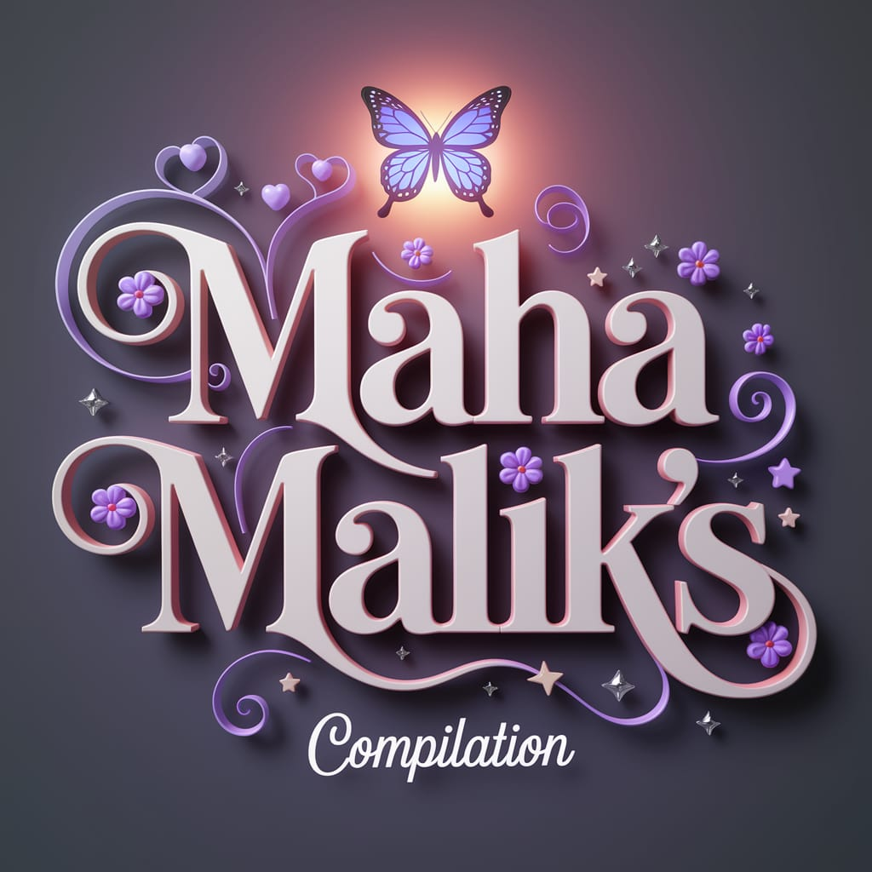  EDU101  Quiz for Final-Term | Abstract  This comprehensive collection of notes is accurately crafted to empower students to excel academically, ensuring they achieve a minimum of 80% marks in their examinations. The content is organized with clarity and precision, focusing on key concepts, critical analyses, and practical applications tailored to the syllabus. These notes serve as a reliable resource for both thorough preparation and last-minute revision. Designed to inspire confidence and mastery, this guide is an essential tool for students striving for academic excellence.  Maha Malik  Foundations of Education

- According to 1972, Semester system was started at university level.
- The 1992 policy stressed on critical thinking opposed to rote learning.
- PHD and M.Phil was recommended in 1992.
- Setting up for national testing system for standardized is introduced in 1992 policy.
- The Constitution of Islamic Republic of Pakistan promises that “The State shall remove illiteracy and provide free and compulsory secondary education within minimum possible period.”
- Environmental issues and concerns can be addressed through global cooperation.
- Accommodation are of two types: teacher and room accommodation.
- Learn regarding sitting properly is an example of room modification.
- A major barrier to successful inclusive education in Pakistan is Attitudes of ordinary school teachers.
- Alberuni, a philosopher, mathematician, geographer, and astronomer, made a deep study of the Hindu culture, customs, religion and wrote “Kitab-ul Hind”.
- New Philosophies came about: Materialism, Socialism, Positivism is result of industrialization.
- According to Pestalozzi believed that education is for all.
- To learn behavior and rituals based on Vedas in India.
- The first educational conference was held in Karachi in December 1947.
- Discrimination would be based on religion, sex, language.
- Guarantee is given when a person has skills in English the use of language of military and bureaucracy.
- In 1970, education as a subject be included in the curriculum as an optional subject.
- Three-year program offered by polytechnics is diploma.
- Gender has been under review for some time in textbook. (in handouts the answer is equality) a) Role b) Equity c) Disparity d) Stereotyping
- Access to basic education is primitive in ---areas of Pakistan? a) Rural. (not sure) b) Urban
- Primary conflict focuses on power struggle factor.
- Sociological perspective recognizes free will within the context of the power of external circumstances.
- Muhammad Ghauri believed in training his slaves.
- Only Girls has made it possible to re-examine the issue of social justice and promote egalitarian gender relation.
- Human right Right to fresh air, health service, sanitation.
- When every child gets the help needed to learn, it is called inclusive education.
- Religious education be made compulsory at middle stage in 1959.
- An Education Service Commission will soon be set up for the recruitment of teachers in 1998 policy.
- Scientific and technical education be given attention to fulfil the economic needs of the country.
- Urdu as a Medium of Instruction in 1947 constitution.
- In 1970 policy recommended raising primary education up to class a) 8 b) 6 c) 5
- Environmental concern should be viewed as a) Interdisciplinary b) Opened c) Direct d) Indirect
- Functional Theories stresses the interdependence of the social system, how well the parts are integrated with each other.
- Who said “Human beings need the order of a stable society”. a) Socrates b) Confucius. c) plato
- Education under reformation is about a) General literacy. b) Administrative and military skill.
- In 18th century ottoman rule did not tolerate any exception providing a) Tertiary b) Secondary c) primary
- John Dewey emphasizes all except a) Education for employment and life b) Education is life, it is not preparation for life. c) Teacher must be a guide to students not a dictator. d) Permits a child to thrive through action.
- What are the reasons cited in the 1978 for not meeting literacy? a) Less increase in number of students b) Less facilities for Teachers c) All of these.
- What was the main objective in 1947 constitution? (answer not sure but read this
B.Ed. (1.5 Years) BS English Files

