
Laboratory Manual
Methods in Molecular Biology
MB504P

Virtual University of Pakistan
Contents

S. No. | Practical | P. No.
1 | Preparation of stock and working solutions | 3
2 | Isolation of DNA (Part I) | 6
3 | Isolation of DNA (Part II) | 9
4 | Quantification of DNA by Gel Electrophoresis | 10
5 | Isolation of RNA | 11
6 | Quantification of RNA by Nanodrop | 12
7 | Restriction digestion of DNA and preparation of restriction maps | 13
8 | Polymerase Chain Reaction (PCR) | 16
9 | Types of PCR and Application | 22
10 | Detection of mutations by Restriction Fragment Length Polymorphism (RFLP) | 24
11 | Preparation of Chemically Competent Cells | 27
12 | Transformation of bacteria with plasmid DNA | 29
13 | Isolation of bacterial Plasmid | 31
14 | Analysis of proteins by SDS-PAGE | 34

Practical No: 1 Preparation of Reagents

The following general instructions are applicable in the preparation of all reagents. Use graduated cylinders or pipettes closest to the volume being measured for preparing liquid reagents. Store all reagents in sterile containers unless otherwise noted. Label all reagents with name of reagent, date prepared, initials of scientist that prepared reagent, lot number, and expiration date. Record each preparation in the lab’s reagent logbook.

1M Tris-HCl (Tris Hydroxymethyl amino methane) pH 8
Tris base 121.1g
H₂O to 800ml
Adjust to desired pH with concentrated HCl. Mix and add H₂O to 1 Liter.
Store at room temperature

0.5 M EDTA (Ethylenediamine Tetra acetic Acid) pH 8.0
Na₂EDTA.2H2O 186.1g
H₂O to 700ml
Adjust pH to 8.0 with 10M NaOH (almost 50ml) Mix and add H₂O to 1 Liter.
Store at room temperature

10M NaOH
NaOH 400 g
H₂O to 1 Liter Store at room temperature

10 mg/ml Ethidium Bromide
Ethidium Bromide 0.2 g H₂O to 20ml
Mix well and store at 4ºC in dark

TE (Tris 10 mM-EDTA 2mM) pH 8.0 (Lysis Buffer)
1M Tris-HCl ph 8.0 10 ml
0.5 M EDTA pH 8.0 4 ml
H₂O to 1 Liter
Store at room temperature

Low TE (Tris 10 mM-EDTA 0.2 mM) pH 8.0 for DNA storage
1M Tris-HCl pH 8.0 10 ml
0.5 M EDTA pH 8.0 0.4 ml
H₂O to 1 Lite
Store at room temperature

Proteinase K (10mg/ml)
Proteinase K 100 mg lyophilized powder in Ultra-pure H2O to 10 ml.
Make the aliquot and store at approximately -20 C

TEN buffer (10mM Tris, 2mM EDTA, 400 mM NaCl)
1 M Tris-HCl pH 8.0 10 ml
5M NaCl 80 ml
0.5M EDTA 4 ml
H₂O to 1 Liter
Store at room temperature

SDS 10% w/v
Sodium dodecyl sulfate 100g H2O to 700ml Heat to approximately 65oC to dissolve.
Bring to a final volume of 1.0 L with ultra-pure water.
Store at room temperature
CAUTION: SDS can be irritating to mucous membranes. Wear safety glasses, mask and gloves when handling

50x TAE (Tris-Acetate-EDTA) Electrophoresis Stock buffer
Tris base 242g
Glacial acetic acid 57.1 ml
0.5 M EDTA pH 8.0 100ml H₂O to 1 Liter
Store at room temperature

1x TAE (Tris 40mM, Acetate 20mM, EDTA 2mM) Electrophoresis working buffer
50x TAE 10 ml H₂O to 500 ml the pH of diluted buffer is 8.3.
Store at room temperature

10x TBE (Tris 90mM-Borate 90mM-EDTA 2mM) Electrophoresis buffer
Tris base 108g
Boric Acid 55g
0.5M EDTA (pH 8.0) 40 ml H₂O to 1 Liter Store at room temperature

2x Gel Loading Dye
2% Bromophenol blue 0.25 ml
2% Xylene cyanol 0.25 ml
Glycerol 7ml
H₂O 10ml
Store at room temperature

5M Sodium Chloride
Sodium Chloride 292.2 g
H₂O to 1 Liter
Store at room temperature

6M Sodium Chloride
Sodium Chloride 351g H₂O to 1 Liter and
Store at room temperature

Practical no: 2 Isolation of DNA part A
Sources of DNA
Purified DNA is required for a variety of molecular biology applications. DNA can be purified from any living organism and its living parts
Origin of Samples:
- Human tissues i.e. histological samples, prenatal samples, postmortem harvesting
- Blood, (EDTA)
- Hair, (follicle part of the hair to be specific
- Rodent tissues, as rats are the most common lab mammals used in labs
- Leaf
- Bacteria, Bacterial cultures
- Yeast, yeast cultures
- Fungi
- Insect, i.e. Drosophila melanogaster
- Stool
- Body fluids, i.e. semen
- Spores
- Soil
- Clinical samples (e.g. biopsy samples, fine needle aspirates)
- Forensic samples (e.g. dried blood spots, buccal swabs finger prints)

DNA extraction is used to isolate
Types of DNA
Mitochondrial DNA
Genomic DNA
Plasmid DNA

DNA Extraction from Whole Blood
Materials
- Lysis buffer (TE)
- Proteinase K
- Phenol-chloroform isoamyl alcohol (PCI)
- SDS 10%
- TNE buffer
- Isopropanol
- Ice cold 95-100% ethanol
- Ultrapure (DNA- & DNase-free) water
Lab equipment needed
- Pippetes,
- 1.5mL sterile microcentrifuge tubes or 15, 50 mL Falcons,
- Racks,
- Tips
- Vortex
- Freezer
- Centrifuge
Blood Sample
Blood collection in anticoagulant i.e. Ethylenediamide tetra-acetic acid (0.5 M EDTA) containing tube 1.5 mL eppendorf or 15 mL Falcon tube
Storage of Blood Samples
Field blood samples should be place on ice immediately after their collection store in freezer at -20°C before
DNA extraction
Steps in Organic DNA Extraction
1- Lysis of Red Blood Cells, RBC
2- Digestion step (Lysis of White blood cells, WBC)
3- Phase Separation step (Extraction of Protein)
4- DNA Precipitation
5- Washing with ice cold Ethanol
6- Dilute the pellet
1. Lysis of Red Blood Cells, RBC
- Lysis of red blood cells
- Added 800 uL of Tris EDTA buffer (Tris HCl 10mM, EDTA 2mM) in 200 uL ml of the blood. Mixed by inverting several times.
- Centrifuged at 5000 rpm for 10 min.
- Discarded the supernatant.
- Break the pellet formed at the bottom of the eppendorf tube by tapping it gently. Add 1 mL TE buffer and mixed it gently.
- Centrifuged at 5000 rpm for 10 min. this step may be repeated until pallet becomes light pink.
2. Digestion step (Lysis of White blood cells, WBC)
- Pellet obtained after lysis of RBCs re-suspended in
- 400 uL Buffer TNE (Tris HCL 10mM, EDTA 2mM, NaCl 400mM),
- 200uL 10% SDS
- 50 uL Proteinase K (50 l of 10µg/uL conc.).
- Homogenize the tube with gentle rotation
- Samples incubate at overnight in 58 °C in shaker water bath.
- Next Day

Practical no: 3 Isolation of DNA part B

3. Phase Separation step (Extraction of Protein)
- In this step, we can remove the digested protein through
- Phenol-chloroform isoamyl alcohol (PCI, in ratio 25:24:1 respectively) (Organic Method).
- DNA released into solution is extracted with PCI to remove proteinaceous materials.
- Add equal volume of phenol-chloroform-isoamyl (PCI) alcohol Mix gently for 2 min and centrifuge for 10 minutes at 10,000 rpm at 4C.
- Carefully remove the top (aqueous) phase containing the DNA using a 1000-ul pipette transfer to a new tube.
4. DNA Precipitation
- Precipitate the DNA with absolute isopropanol and inverted the tubes gently till DNA threads became visible and then left the tubes at room temperature for 10 minutes.
- Centrifuged at 8000 rpm for 10 minutes and discarded the supernatant carefully and white pellet of DNA may visible at the bottom of the tube.
5. Washing with ice cold Ethanol
- Washed DNA pellet with 1 mL of 70-100% ethanol, break and mix the pellet
- Then centrifuged at 8000 rpm for 10 minutes and discarded the supernatant carefully
- Air dried the DNA pellet at room temperature for at least 2 hours
6. Dilute the pellet
- Add 50-100 uL of low T.E. (Tris HCl 10 mL, EDTA 0.2mM) or DEPC water
- Place the tubes in a shaking water bath at 70°C for one hour so that nucleases were inactivated. Finally DNA will store at –20ºC.

Practical no: 4 Quantification of DNA by Gel Electrophoresis

DNA Quantification
DNA yield can be assessed using various methods including absorbance (optical density), agarose gel electrophoresis.
Agarose gel electrophoresis
Agarose gel electrophoresis is another way to quickly estimate DNA concentration. To use this method, a horizontal gel electrophoresis tank with an external power supply, analytical-grade agarose, an appropriate running buffer (e.g., 1X TAE) and an intercalating DNA dye along with appropriately sized DNA standards are required. A sample of the isolated DNA is loaded into a well of the agarose gel and then exposed to an electric field. For the quantification and quality of DNA,
0.8 % Agarose gel was prepared by boiling 0.8 g of Agarose in 100 mL of 1X TAE buffer.
As the temperature of gel solution reduced to approximately 55°C, Ethidium bromide (Conc.10mg/mL) add at the rate of of 5 μL/100 ml of gel solution.
Melted agarose was poured into gel casting tray with comb (10-20 wells) position appropriately.
When the gel get solidify, transfer into electrophoresis tank filled with 1X TAE buffer.
The level of buffer keep at least 1 cm above the gel
The wells carefully load with 5 μL DNA mixed with 3 μL 3X Bromophenol blue (gel loading dye).
Standard DNA ladder load along with the DNA samples in a separate well
Electrophoresis carries out at 100V for 30-60 min.
On completion of electrophoresis, the gel visualizes under UV light in Gel documentation system and estimate the quality and quantity.
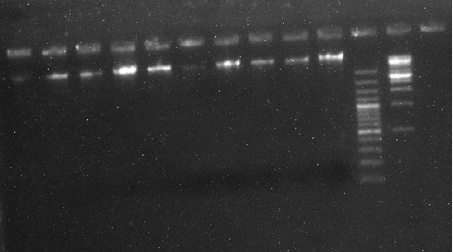
Fig 4.1: Bands of DNA

Practical no: 5 Isolation of RNA by Trizol method

RNA extraction by Trizol reagents
- Take 200 uL samples in a 1.5 mL eppendorff and add 800uL Trizol and 200 uL chloroform, mixed and centrifuge for 15 minutes at 12,000g.
- Transfer the upper equous layer to a new eppendorff
- Add 500 uL isopropanol and place at -40C for ½ hour
- Centrifuge at 12,000g for 10 minutes
- Discard supernatant and add 1 mL 75% ethanol and centrifuge at 7500g for 5 minutes
- Discard supernatant and add 1mL 100% ethanol and centrifuge at 7500g for 5 minutes
- Dry and add 20uL DECP water
RNA extraction by Trizol reagents
- Collect 250 uL samples to a 1.5 mL eppendorff and add 750uL Trizol and samples is overtex for 15 sec. incubate at room temperature for 7 minutes.
- Pulse spin to remove liquid from the tube lid.
- Add 200uL 100% chloroform to the sample, vortex for 15 sec and incubate at room temperature for 7 minutes.
- Centrifuge at 12,000g for minutes at room temperature.
- Transfer 450uL of the upper aqueous layer to a separate microcentrifuge tube.
- Add 500uL 100% isopropanol, invert tube several time to mix and hold at room temperature for 10 minutes.
- Discard supernatant. Care should be taken to assure that the RNA pellet is not disturbed.
- Add 1 mL of 80% ethanol. Mix gently.
- Centrifuge at 10,000g for 5 minute at 4°C.
- Discard ethanol. Invert tube on a clean tissue wipe and allow to air dry for 10 minutes. It is important not to let the RNA pellet over dry as this will decrease its solubility.
- Hydrate pellet in 50 uL of RNase free water and allow sitting at 4°C for 1 hr to overnight. Briefly vortex to resuspend pellet before pipetting.

Practical no: 6 Quantification of RNA by Nanodrop

Nanodrop (Spectrophotometer)
The most common technique to determine DNARNA yield and purity is measurement of absorbance using Nanodrop. A spectrophotometer is able to determine the average concentrations of the nucleic acids DNA or RNA present in a mixture, as well as their purity. The absorbance method is a spectrophotometer equipped with a UV lamp, and a solution of purified DNA/RNA sample. DNA concentration is estimated by measuring the absorbance at 260nm. To evaluate DNA purity, measure absorbance from 230 nm to detect other possible contaminants. The most common purity calculation is the ratio of the absorbance at 260nm divided by the reading at 280nm (Protein detection). Good-quality DNA will have an A_{260/280} is widely considered ~1.8 and for RNA is ~2.0. A reading of 1.7, 1.6 etc does not render the DNA unsuitable for any application, but lower ratios indicate more contaminants are present.
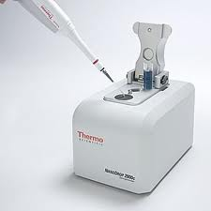
Fig 6.1: Nanodrop
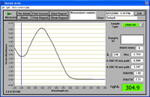
Fig 6.2: Measurement box

Practical no: 7 Restriction digestion of DNA and preparation of restriction maps

Introduction
Restriction enzyme mapping is a powerful tool for the analysis of DNA. This technique relies on restriction endonucleases, hundreds of which are now available, each one recognizing and reproducibly cleaving a specific base pair (bp) sequence in double-stranded DNA thus generating fragments of varying sizes. Since the rate at which a DNA molecule moves through an agarose gel during electrophoresis is inversely proportional to its size, 1 the lengths of these DNA fragments can be ascertained and this information used to determine the positions of cleavage sites in a DNA molecule. Comparative analysis of fragments generated by cleavage with two different restriction endonucleases enables the molecular biologist to determine the relative location of particular recognition sequences in the DNA molecule.
Restriction mapping has widely publicized applications. These include DNA fingerprinting, the detection of genetic defects and the sequencing of the human genome. Although students readily appreciate the importance of this new methodology, they often find it difficult to understand the techniques and logic involved. The experiments and mapping exercises described below introduce students to the methods used in the restriction enzyme analysis of DNA. This laboratory has been used effectively in both introductory and advanced undergraduate courses. The use of predigested DNA fragments helps to insure the success of the experiment and to reduce costs. Restriction mapping exercises are designed to provide students with tangible experience in the abstract reasoning required for accurate interpretation of results. These exercises are meant to be carried out during electrophoresis of student samples.
Principle
Restriction enzymes, also called restriction endonucleases, recognize specific base sequences in double-helical DNA and cleave, at specific places, both strands containing the recognized sequences. Many restriction enzymes recognize specific sequences of 4 to 8 base pairs and hydrolyze a phosphodiester bond in each strand in the region. A striking characteristic of these "cleavage sites" is that the recognition sequence is palindromic.
Aim of the Practical
- Understand what a DNA restriction enzyme is and how it works.
- Learn to use a micropipette.
- Learn to separate DNA on an agarose gel using electrophoresis.
- Understand how to use a restriction digestion map to identify a sample DNA.
- Compare the λ DNA bands on a gel to the known λ DNA restriction map.
Materials
Reagents
- Four microtubes
- Microtube rack
- 20-µl micropipette (or 10-µl micropipette) and sterile tips
- Waterproof pen
- Beaker or foam cup with crushed ice for the following
- 20 µl of 0.4 µg/µl DNA
- µl BamHI restriction enzyme
- µl EcoRI restriction enzyme
- 2.5 µl HindIII restriction enzyme
- 10 µl distilled water
- Gloves
- 500-ml beaker
- Electrophoresis chamber
- Power supply
- 20 µl 10X loading dye
- 1.0% agarose gel
Common Materials
- Container with TBE solution (1X)
- 37°C water bath w/ floating rack
- 60°C water bath or saucepan on a hot plate
- Cooler with crushed ice
- Freezer (non frost-free, if possible)
- Camera if desired
- Distilled water
- 0.002% methylene blue stain
Method
Cut the DNA with each enzyme singly, and with all possible pairwise combinations.
Analyze samples of the restriction digests, along with a marker, by agarose gel electrophoresis.
Using ethidium bromide and UV light exposure, visualize the DNA bands and take a photograph. (Note: ethidium bromide was incorporated into your agarose gel in lab.)
The resultant fragments are separated by agarose electrophoresis and their sizes (in base pairs) are determined by comparing them with a standard size marker.
The process of assembling a map is a somewhat trial and error process in which you construct possible maps, predict the sizes of fragments obtained from this map and compare the predictions with the actual data.
The correct map is the one that accounts for all of the bands seen on the gel. Although the process is trial and error there are several steps that will simplify the process

Practical no: 8 Polymerase Chain Reaction (PCR)

The polymerase chain reaction (PCR) is the cardinal laboratory technology of molecular biology. Arguably one of the most powerful laboratory techniques ever discovered, PCR combines the unique attributes of being very sensitive and specific with a great degree of flexibility. With the PCR it is possible to specifically address a particular DNA sequence and to amplify this sequence to extremely high copy numbers. Since its initial development in the early 1980’s, dozens of variations in the basic theme of PCR have successfully been carried out. In fact, the very flexibility and application-specific
variation of PCR make it seem like there are as many ways to do a PCR reaction as there are researchers doing them. Here, a basic, straight-forward PCR protocol is presented. Where appropriate, some of the choices for modifying this standard reaction that are routinely available to researchers are discussed.
Materials and Reagents
- Tris-HCl
- MgCl2
- Taq DNA polymerase
- dNTPs
- Template DNA (genomic, plasmid, cosmid, bacterial/yeast colony, etc.)
- Primers
- Water
Equipment
Thermal cycler (MJ Research)
Primers
Designing appropriate primers is essential to the successful outcome of a PCR experiment. When designing a set of primers to a specific region of DNA desired for amplification, one primer should anneal to the plus strand, which by convention is oriented in the 5' → 3' direction (also known as the sense or nontemplate strand) and the other primer should complement the minus strand, which is oriented in the 3' → 5' direction (antisense or template strand).
There are a few common problems that arise when designing primers:
1) Self-annealing of primers resulting in formation of secondary structures such as hairpin loops
2) Primer annealing to each other, rather than the DNA template, creating primer dimers
3) Drastically different melting temperatures (Tm) for each primer, making it difficult to select an annealing temperature that will allow both primers to efficiently bind to their target sequence during themal cycling
Below is a list of characteristics that should be considered when designing primers.
- Primer length should be 15-30 nucleotide residues (bases).
- Optimal G-C content should range between 40-60%.
- The 3' end of primers should contain a G or C in order to clamp the primer and prevent "breathing" of ends, increasing priming efficiency. DNA "breathing" occurs when ends do not stay annealed but fray or split apart. The three hydrogen bonds in GC pairs help prevent breathing but also increase the melting temperature of the primers.
- The 3' ends of a primer set, which includes a plus strand primer and a minus strand primer, should not be complementary to each other, nor can the 3' end of a single primer be complementary to other sequences in the primer. These two scenarios result in formation of primer dimers and hairpin loop structures, respectively.
- Optimal melting temperatures (Tm) for primers range between 52-58 °C, although the range can be expanded to 45-65 °C. The final Tm for both primers should differ by no more than 5 °C.
- Di-nucleotide repeats (e.g., GCGCGCGCGC or ATATATATAT) or single base runs (e.g., AAAAA or CCCCC) should be avoided as they can cause slipping along the primed segment of DNA and or hairpin loop structures to form. If unavoidable due to nature of the DNA template, then only include repeats or single base runs with a maximum of 4 bases.
Setting up a Reaction Mixture
- Start by making a table of reagents that will be added to the reaction mixture.
- Label PCR tube(s) with the ethanol-resistant marker.
- Reaction volumes will vary depending on the concentrations of the stock reagents. The final concentrations (CF) for a typical 50 μl reaction are as follows.
  - X buffer (usually supplied by the manufacturer of the DNA polymerase; may contain 15 mM MgCl₂). Add 5 μl of 10X buffer per reaction.
  - 200 μM dNTPs (50 μM of each of the four nucleotides). Add 1 μl of 10 mM dNTPs per reaction (dATP, dCTP, dTTP and dGTP are at 2.5 mM each).
  - 1.5 mM Mg²⁺. Add only if it is not present in the 10X buffer or as needed for PCR optimization. For example, to obtain the 4.0 mM Mg²⁺ required for optimal amplicon production of a conserved 566 bp DNA segment found in an uncharacterized Mycobacteriophage add 8 μl of 25 mM MgCl₂ to the reaction.
  - 20 to 50 pmol of each primer. Add 1 μl of each 20 μM primer.
  - Add 10⁴ to 10⁷ molecules (or about 1 to 1000 ng) DNA template. Add 0.5 μl of 2ng/μl genomic Mycobacteriophage DNA.
  - Add 0.5 to 2.5 units of DNA polymerase per 50 μl reaction, For example, add 0.5 μl of Sigma 0.5 Units/μl Taq DNA polymerase.
  - Add Q.S. sterile distilled water to obtain a 50 μl final volume per reaction as pre-determined in the table of reagents. Thus, 33 μl per reaction is required to bring the volume up to 50 μl. However, it should be noted that water is added first but requires initially making a table of reagents and determining the volumes of all other reagents added to the reaction.
Table 8.1: Reagents required for PCR
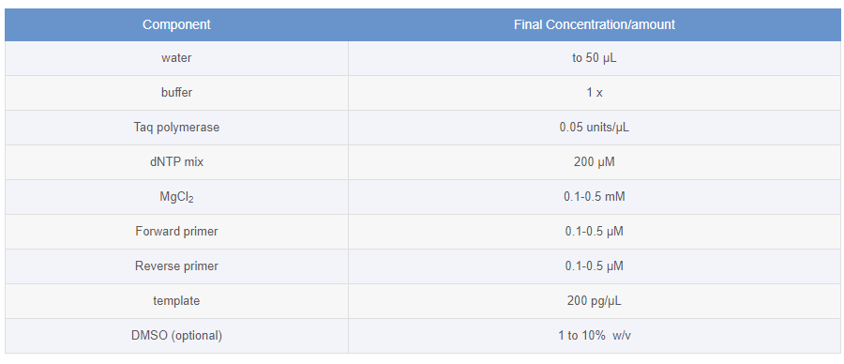

Setting Up Thermal Cycling Conditions
- Denaturation (strand separation): The separation of the two hydrogen-bonded complementary chains of DNA into a pair of single-stranded polynucleotide molecules by a process of heating (94°C to 96°C)
- Annealing (primer binding): The temperature is lowered (45-60 °C) so the primers can attach themselves to the single-stranded DNA strands.
- Extension (synthesis of new DNA): It starts at the annealed primer and works its way along the DNA strand (72°C).
In Details
- PCR thermal cyclers rapidly heat and cool the reaction mixture, allowing for heat-induced denaturation of duplex DNA (strand separation), annealing of primers to the plus and minus strands of the DNA template, and elongation of the PCR product. Cycling times are calculated based on the size of the template and the GC content of the DNA. The general formula starts with an initial denaturation step at 94 °C to 98 °C depending on the optimal temperature for DNA polymerase activity and G-C content of the template DNA. A typical reaction will start with a one minute denaturation at 94 °C. Any longer than 3 minutes may inactivate the DNA polymerase, destroying its enzymatic activity. One method, known as hot-start PCR, drastically extends the initial denaturation time from 3 minutes up to 9 minutes. With hot-start PCR, the DNA polymerase is added after the initial exaggerated denaturation step is finished. This protocol modification avoids likely inactivation of the DNA polymerase enzyme. Refer to the Troubleshooting section of this protocol for more information about hot start PCR and other alternative methods.
- The next step is to set the thermal cycler to initiate the first of 25 to 35 rounds of a three-step temperature cycle (Table 2). While increasing the number of cycles above 35 will result in a greater quantity of PCR products, too many rounds often results in the enrichment of undesirable secondary products. The three temperature steps in a single cycle accomplish three tasks: the first step denatures the template (and in later cycles, the amplicons as well), the second step allows optimal annealing of primers, and the third step permits the DNA polymerase to bind to the DNA template and synthesize the PCR product. The duration and temperature of each step within a cycle may be altered to optimize production of the desired amplicon. The time for the denaturation step is kept as short as possible. Usually 10 to 60 seconds is sufficient for most DNA templates. The denaturation time and temperature may vary depending on the G-C content of the template DNA, as well as the ramp rate, which is the time it takes the thermal cycler to change from one temperature to the next. The temperature for this step is usually the same as that used for the initial denaturation phase (step #1 above; e.g., 94 °C). A 30 second annealing step follows within the cycle at a temperature set about 5 °C below the apparent Tm of the primers (ideally between 52 °C to 58 °C). The cycle concludes with an elongation step. The temperature depends on the DNA polymerase selected for the experiment. For example, Taq DNA polymerase has an optimal elongation temperature of 70 °C to 80 °C and requires 1 minute to elongate the first 2 kb, then requires an extra minute for each additional 1 kb amplified. Pfu DNA Polymerase is another thermostable enzyme that has an optimal elongation temperature of 75 °C. Pfu DNA Polymerase is recommended for use in PCR and primer extension reactions that require high fidelity and requires 2 minutes for every 1 kb to be amplified. See manufacturer recommendations for exact elongation temperatures and elongation time indicated for each specific DNA polymerase.
- The final phase of thermal cycling incorporates an extended elongation period of 5 minutes or longer. This last step allows synthesis of many uncompleted amplicons to finish and, in the case of Taq DNA polymerase, permits the addition of an adenine residue to the 3' ends of all PCR products. This modification is mediated by the terminal transferase activity of Taq DNA polymerase and is useful for subsequent molecular cloning procedures that require a 3'-overhang.
- Termination of the reaction is achieved by chilling the mixture to 4 °C and/or by the addition of EDTA to a final concentration of 10 mM.
Table 8.2: Thermocycler condition
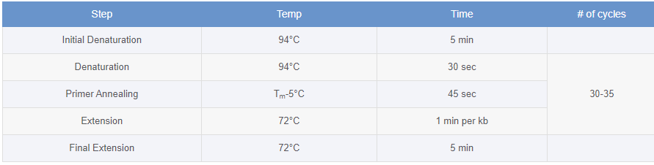

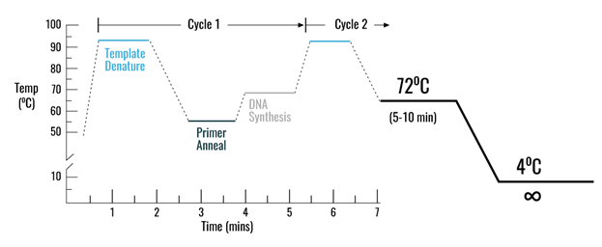
Fig 8.1: PCR condition
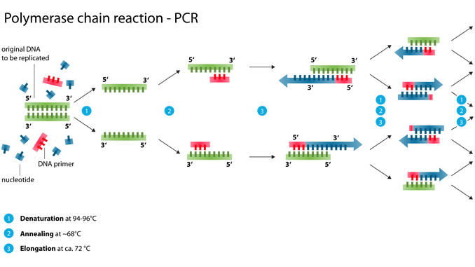
Fig 8.2: PCR reaction process

Practical no: 9 Types of Polymerase Chain Reaction (PCR) and Application

Types of polymerase chain reaction-PCR
Several modifications of PCR methods have been developed to enhance the utility of this method in diagnostic settings based on their applications. Some of the common types of PCR are;
- Real-Time PCR (quantitative PCR or qPCR)
- Reverse-Transcriptase (RT-PCR)
- Gradient PCR
- Touch down PCR
- Multiplex PCR
- Nested PCR
- High Fidelity PCR
- Fast PCR
- Hot Start PCR

Applications of PCR
- Identification and characterization of infectious agents
- Direct detection of microorganisms in patient specimens
- Identification of microorganisms grown in culture
- Detection of antimicrobial resistance
- Investigation of strain relatedness of a pathogen of interest
- Genetic fingerprinting (forensic application/paternity testing)
- Detection of mutation ( investigation of genetic diseases)
- Cloning genes
- PCR sequencing
Touch down PCR
Touchdown (TD) PCR offers a simple and rapid means to optimize PCRs, increasing specificity, sensitivity and yield, without the need for lengthy optimizations and/or the redesigning of primers. TD-PCR employs an initial annealing temperature above the projected melting temperature (Tm) of the primers being used, then progressively transitions to a lower, more permissive annealing temperature over the course of successive cycles. Any difference in Tm between correct and incorrect annealing will produce an exponential advantage of twofold per cycle. TD-PCR has found wide applicability in standard PCR protocols, including reverse transcriptase-dependent PCR, as well as in the generation of cDNA libraries and single nucleotide polymorphism screening. It is a method for increasing specificity of PCR reactions. Touchdown PCR uses a cycling program where the annealing temperature is gradually reduced (e.g. 1-2°C /every second cycle). The initial annealing temperature should be several degrees above the estimated Tm of the primers. The annealing temperature is then gradually decreased until it reaches the calculated annealing temperature of the primers or some degrees below. Amplification is then continued using this annealing temperature.
TD-PCR cycling conditions
The suggested cycling program has two phases. The first phase of touchdown programming uses a Tm that is approximately 10°C above the calculated Tm. The temperature is reduced by 1°C every successive cycle until the calculated Tm range is reached. This is done for a total of 10-15 cycles.
Phase 2 follows generic PCR amplification of up to 20-25 cycles using the final annealing temperature reached in the touchdown phase.
The cycle and temperature drop during touchdown phase can be adjusted from 1-3 cycles per 1-3°C drop in temperature if non-specific products are still observed or if the yield is low.
General Tips for TD-PCR
Keeping all reactions cold until thermal cycling starts is crucial to avoiding non-specific priming even with TD-PCR.
A hot start setup is preferred. Since the main aim of TD-PCR is to eliminate non-specific interactions during the initial cycles, it is important to use a hot-start set up.
TD-PCR can address problems with monoplex reactions better than multiplex reactions.
Total number of PCR cycles, including the touchdown phase should be kept low (below 35). Too many cycles will lead to appearance of non-specific bands in the gel.
An extra 1 min denaturation cycle at 96°C or 97°C may be extremely useful for difficult templates.

Practical no: 10 Detection of mutations by Restriction Fragment Length Polymorphism (RFLP)

Restriction fragment length polymorphism (RFLP) is a technique invented in 1984 by the English scientist Alec Jeffreys during research into hereditary diseases. It is used for the analysis of unique patterns in DNA fragments in order to genetically differentiate between organisms – these patterns are called Variable Number of Tandem Repeats (VNTRs).
Genetic polymorphism is defined as the inherited genetic differences among individuals in over 1% of normal population. The RFLP technique exploits these differences in DNA sequences to recognize and study both intraspecies and interspecies variation.
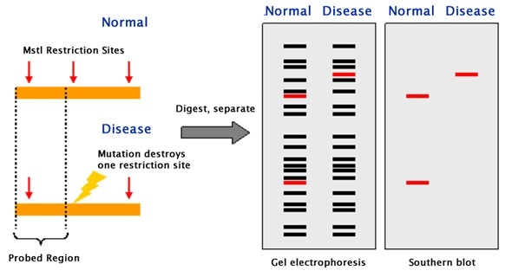
Fig 10.1: Pattern of RFLP
Principle
Restriction endonucleases are enzymes that cut lengthy DNA into short pieces. Each restriction endonuclease targets different nucleotide sequences in a DNA strand and therefore cuts at different sites.
The distance between the cleavage sites of a certain restriction endonuclease differs between individuals. Hence, the length of the DNA fragments produced by a restriction endonuclease will differ across both individual organisms and species.
How does it Work?
RFLP is performed using a series of steps briefly outlined below:
DNA Extraction
To begin with, DNA is extracted from blood, saliva or other samples and purified.
DNA Fragmentation
The purified DNA is digested using restriction endonucleases. The recognition sites of these enzymes are generally 4 to 6 base pairs in length. The shorter the sequence recognized, the greater the number of fragments generated from digestion.
For example, if there is a short sequence of GAGC that occurs repeatedly in a sample of DNA. The restriction endonuclease that recognizes the GAGC sequence cuts the DNA at every repetition of the GAGC pattern.
If one sample repeats the GAGC sequence 4 times whilst another sample repeats it 2 times, the length of the fragments generated by the enzyme for the two samples will be different.
Gel Electrophoresis
The restriction fragments produced during DNA fragmentation are analyzed using gel electrophoresis.
The fragments are negatively charged and can be easily separated by electrophoresis, which separates molecules based on their size and charge. The fragmented DNA samples are placed in the chamber containing the electrophoretic gel and two electrodes.
When an electric field is applied, the fragments migrate towards the positive electrode. Smaller fragments move faster through the gel leaving the larger ones behind and thus the DNA samples are separated into distinct bands on the gel.
Visualization of Bands
The gel is treated with luminescent dyes in order to make the DNA bands visible.
Applications of RFLP
RFLP has been used for several genetic analysis applications since its invention.
Some of these key applications of RFLP are listed below:
- To determine the status of genetic diseases such as Cystic Fibrosis in an individual.
- To determine or confirm the source of a DNA sample such as in paternity tests or criminal investigations.
- In genetic mapping to determine recombination rates that show the genetic distance between the loci.
- To identify a carrier of a disease-causing mutation in a family.
Disadvantages of RFLP
- Since its invention, RFLP has been a widely used genome analysis techniques employed in forensic science, medicine, and genetic studies. However, it has become almost obsolete with the advent of relatively simple and less expensive DNA profiling technologies such as the polymerase chain reaction (PCR).
- The RFLP procedure requires numerous steps and takes weeks to yield results, while techniques such as PCR can amplify target DNA sequences in a mere few hours.

Practical no: 11 Preparation of chemically competent Cell

Materials and Reagents
- Luria-Bertani broth (LB) medium: Bacto-tryptone (BD Biosciences), yeast extract
- Antibiotics
- QIAGEN Plasmid Purification Handbook
- SeaKem® LE Agarose
- Plasmid Prep Kit (QIAGEN /Fermentas)
- PCR Clean-up kit (QIAGEN /Fermentas)
- Restriction enzymes (New England Biolabs)
- Alkaline Phosphatase: Calf intestinal alkaline phosphatase (CIP) or Shrimp Alkaline Phosphatase (SAP)
- Ligase enzyme
- DNA ladder
- NaCl
- LB broth media
- Ligation reaction
Protocol
Preparing transformation competent E. coli using CaCl2
- It is very important that sterile technique be strictly observed through the prep. All centrifuge bottles, tubes, solutions, pipets, etc. must be sterile. Any contamination during the prep will result in problems for everyone in the lab who uses the competent cells for cloning, thereby probably decreasing your popularity.
- Inoculate 1 ml of LB with cells from a frozen glycerol stock and incubate overnight at 37ºC.
- Transfer the entire 1 ml into a 1 L erlenmeyer flask containing 500 ml LB and incubate at 37ºC.
- Monitor growth starting at about 2 hours by measuring OD of an aliquot. Let cells grow until the OD550 = 0.45 to 0.6. This should take approximately 4 hours.
- Transfer the culture to 2 x 500 ml centrifuge bottles and chill on ice to 4ºC.
- Centrifuge at 6,000 g for 5 min at 4ºC.
- Pour off supernatant and pipette off remaining supernatant.
- Resuspend each pellet in 125 ml ice cold 50mM CaCl2. Combine into a single 500 ml centrifuge bottle.
- Centrifuge at 6,000 g for 5 min at 4ºC.
- Pour off supernatant and resuspend in 21.5 ml ice cold 50 mM CaCl2
- Add 3.5 ml sterile glycerol (100%) and mix gently
- Prepare 500 µl aliquots in sterile microfuge tubes and snap freeze in liquid nitrogen
- Store in -80ºC freezer. Use within 6 months if possible

Practical no: 12 Transformation of bacteria with plasmid DNA

Introduction
Bacterial transformation is a process of horizontal gene transfer by which some bacteria take up foreign genetic material (naked DNA) from the environment. It was first reported in Streptococcus pneumonia by Griffith in 1928. DNA as the transforming principle was demonstrated by Avery et al in 1944.
Principle
Transformation process allows a bacterium to take up genes from its surrounding environment; that is transformation involves the direct uptakes of fragments of DNA by a recipient cell and the acquisition of new genetic characteristics. There are two major parameters involved in efficiently transforming a bacterial organism. The first is the method used to induce competence for transformation. The second major parameter is the genetic constitution of the host strain of the organism being transformed. Competent cells are capable of up taking DNA from their environment.
Transforming chemically competent E. coli using heat shock
- E. coli cells are stored at -80ºc in aliquots of 500 µl. Thaw one vial on ice. Generally need 100 µl for each transformation. It is best not to refreeze whatever is left over, just throw it away.
- For each transformation, pipet 100 µl of competent cells into a sterile 1.5 ml microfuge tube.
- Add DNA (5-10 ul of PCR product or 1 µl plasmid) to each tube and incubate on ice for 20-25 mins (can be as short as 5 min). This allows the DNA to adsorb to cell surfaces.
- Heat shocks the cells/DNA to allow uptake of DNA into cells. Place tubes in 42º C water bath for 45 seconds. Variation: place all tubes at 370C for 2 mins. Return cells to ice.
- Add 1 ml of LB or SOC to each tube and incubate at 37ºC for 45-60 mins in a shaking incubator to let the cells recover from the heat shock and start growing again. Liquid should appear cloudy at this point.
- Streak the cells onto agar plates with the correct antibiotic. If you are using blue/white selection remember to coat the plates with 40 µl of 2% X-gal in DMSO at least one hour before streaking the bacteria. I usually streak two plates for each transformation. On one plate streak 50 µl of the 1 ml cell slurry. Spin the remaining 950 µl by placing in a table-top centrifuge and bringing the speed up to 12,000 g for one or two seconds. This should pellet the cells. Pour off the majority of LB/SOC, then resuspend the pellet in the remaining ~100 µl and spread this on the second plate.
- Incubate plates at 37ºC overnight.
- Pick colonies the next day

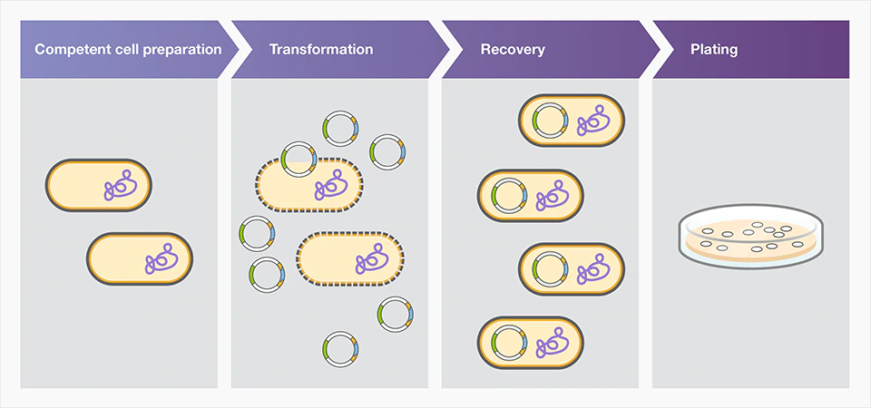
Fig 12.1: Transformation of bacterial plasmid

Practical no: 13 Isolation of bacterial Plasmid

While genomic DNA extraction is pretty straightforward, extracting plasmid DNA can be a little more complicated since you should be able to identify and use the appropriate lysis method to successfully separate the plasmid DNA from the gDNA. Basically, a milder treatment (i.e. alkaline lysis) is required when extracting plasmid DNA. Here’s how you go about extracting them.
- Cell Cultivation
The procedure starts with the cultivation of bacterial cells in varying amounts of growth medium. When sufficient growth is achieved, you can remove the cells from the medium through centrifugation.
- Resuspension and Cell Lysis
A cell pellet from the saturated culture is resuspended in an isotonic solution containing Tris, EDTA (to disrupt the cell wall and prevent DNases from damaging the plasmid), glucose (to prevent the cells from bursting) and RNase A (to degrade cellular RNA during cell lysis). An alkaline solution containing sodium dodecyl sulfate (SDS) is then added to facilitate cell lysis and the complete denaturation of both genomic and plasmid DNA along with all the proteins in the solution.
- Neutralization, Cleaning and Concentration
A potassium acetate solution is then used to neutralize the sample and separate the plasmid DNA from the gDNA. The smaller plasmid DNA tends to renature easily while the larger, more complicated gDNA remains denatured and precipitates out of the solution.
Upon centrifugation, gDNA will form a pellet while plasmid DNA remains soluble. The plasmid DNA remaining in the supernatant can then be precipitated with ethanol or purified using a phenol-chloroform mixture or spin filter technology.

Some Tips to Consider for Plasmid DNA Extraction:
- The cell lysis step should be done quickly since overdoing it can irreversibly denature the plasmid.
- While the resuspension and lysis buffers should be mixed thoroughly, make sure you do not vortex or mix it vigorously to prevent the DNA from breaking into smaller fragments. If they are small enough, broken gDNA can reanneal and remain in the solution.
- Wear gloves and appropriate eye protection when working with harsh chemicals such as NaOH and SDS.
E. coli Plasmid DNA MiniPrep Protocol
Introduction
The isolation of plasmid DNA from E. coli using an alkaline lysis is a well-established method. E. coli with plasmid is cultured in media with antibiotics to a high cell density, harvested, and then lysed with a SDS/NaOH solution. Rapid acidification using concentrated potassium acetate causes the precipitation of protein and chromosomal DNA. Plasmid DNA, which is supercoiled, remains in solution and can be captured on a silica spin column. The plasmid DNA is washed with an ethanol solution and then eluted in water or TE buffer.
Material
- Microfuge tubes
- Resuspension buffer (50 mM Tris HCl, pH 8, 10 mM EDTA, 100 µg/ml RNase A)
- Lysis buffer (0.2 N NaOH, 1% SDS)
- Neutralization buffer (3/5 M Potassium acetate, pH 6)
- Spin columns (Product Number SSC 100-01)
- Isopropanol
- Wash buffer (70% Ethanol)
- Elution buffer (water or TE buffer- 10 mM Tris, pH 8, 1 mM EDTA)
Equipment
- Vortexer
- Centrifuge
Protocol
- Culture E. coli with plasmid in LB media with antibiotic selective pressure, overnight on a shaker at 37°C.
- Pellet 1.5 ml of bacterial culture in a microfuge tube by centrifuging for 2 minutes at 10,000 rpm.
- Decant the supernatant and add 200 µl of the resuspension buffer. In order to resuspend the pellet you may have to vortex.
- Add 250 µl of the lysis buffer, invert the tube 10 times to mix thoroughly. The solution should become clear and viscous.
- Add 350 µl of the neutralization buffer, invert the tube 10 times or until a precipitate forms. The precipitate is a mixture of protein and chromosomal DNA.
- Centrifuge the tube for 10 minutes at 10,000 rpm. Transfer the supernatant to a microfuge tube and add 0.7 isopropanol. Incubate at -20°C for 15 minutes.
- Transfer the solution to a spin column.
- Centrifuge the spin column for 1 minute at 7,000 rpm. Discard the flow through.
- Add 400 µl of the wash buffer and centrifuge for 1 minute at 7,000 rpm. Discard the flow through. Repeat this step.
- Centrifuge for an additional 2 minutes at 10,000 rpm to remove residual wash buffer.
- Transfer the column to a clean microfuge tube. Add 50 µl of elution buffer and centrifuge for 1 minute at 10,000 rpm.

Practical no: 14 Analysis of proteins by SDS-PAGE

SDS-PAGE
The purpose of SDS-PAGE is to separate proteins according to their size, and no other physical feature. In order to understand how this works, we have to understand two halves of the name: SDS and PAGE.
In this Technique we are trying to separate many different protein molecules of different shapes and sizes, we first want to denature so that the proteins no longer have any secondary, tertiary or quaternary structure (i.e. we want them to retain only their primary amino acid structure). Consider two proteins that are each 500 amino acids long but one is shaped like a closed umbrella while the other one looks like an open umbrella. If you tried to run down the street with both of these molecules under your arms, which one would be more likely to slow you down, even though they weigh exactly the same? This analogy illustrates mass and the 3D structure of a molecule will determine how well it can move through an environment. We use SDS to denature all proteins to the same linear shape.
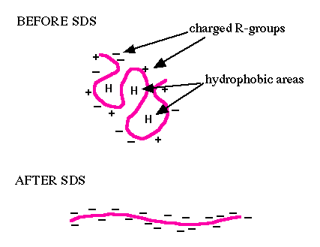
Fig 14.1: Before and after SDS
SDS (sodium dodecyl sulfate) is a detergent (soap) that can dissolve hydrophobic molecules but also has a negative charge (sulfate) attached to it. Therefore, if a cell is incubated with SDS, the membranes will be dissolved, all the proteins will be solublized by the detergent, plus all the proteins will be covered with many negative charges. The end result has two important features:
1) All proteins retain only their primary structure
2) All proteins have a large negative charge which means they will all migrate towards the positive pole when placed in an electric field.
PAGE
If the proteins are denatured and put into an electric field, they will all move towards the positive pole at the same rate, with no separation by size. So we need to put the proteins into an environment that will allow different sized proteins to move at different rates. The environment of choice is polyacrylamide, which is a polymer of acrylamide monomers. When this polymer is formed, it turns into a gel and we will use electricity to pull the proteins through the gel so the entire process is called polyacrylamide gel electrophoresis (PAGE). A polyacrylamide gel is not solid but is made of a laberynth of tunnels through a meshwork of fibers.
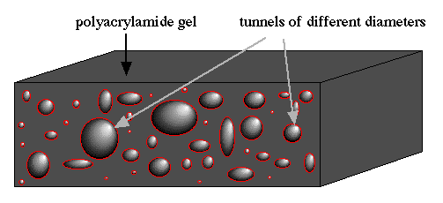
Fig 14.2: This picture shows a slab of polyacrylamide (dark gray) with tunnels (different sized red rings with shading to depict depth) exposed on the edge. Notice that there are many different sizes of tunnels scattered randomly throughout the gel.

Figure of Running Gel
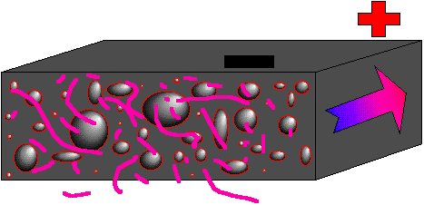
Fig 14.3: Showing a mixture of denatured proteins (pink lines of different lengths) beginning their journey through a polyacrylamide gel (gray slab with tunnels). An electric filed is established with the positive pole (red plus) at the far end and the negative pole (black minus) at the closer end. Since all the proteins have strong negative charges, they will all move in the direction the arrow is pointing (run to red).

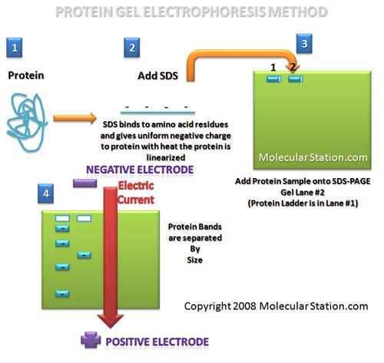
Fig 14.4: Hypothetical Figure of Gel
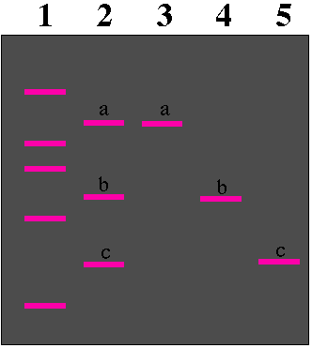
Fig 14.5: Top view of an SDS PAGE after the current has been on for a while (positive pole at the bottom) and then turned off. The gel (gray box) has five numbered lanes where five different samples of proteins (many copies of each kind of protein) were applied to the gel. (Lane 1, molecular weight standards of known sizes; Lane 2, a mixture of three proteins of different sizes with a being the largest and c being the smallest protein; Lane 3, protein a by itself; Lane 4, protein b by itself; Lane 5 protein c by itself.) Notice that each group of the three proteins migrated the same distance in the gel whether they were with other proteins (lane 2) or not (lanes 3-5). The molecular weight standards are used to measure the relative sizes of the unknown proteins (a, b, and c).
Preparations of Buffer (Discontinuous buffer system)
Separating gel buffer (1.5 M Tris-HCl, pH 8.8)
A 36.6 g Tris base is dissolved in 170 ml of the distilled water and pH is adjusted to 8.8 with diluted HCl. The water is added to a total volume of 200 ml and is stored at 4ºC.

Stacking gel buffer (0.5 M Trist-HCl, pH 6.8)
A 1.21 g of Tris-base is dissolved in 170 ml of the distilled water and pH is adjusted to 6.8 with diluted HCl. The water is added to a total volume of 200 ml and is stored at 4ºC.
2X sample buffer (for liquid samples)
The following solutions are dispensed in a 10 ml measuring cylinder:
Glycerol (10%) 1.00 ml
Tris-HCl, pH 6.8 (0.5 M) 1.25 ml
SDS (10%) 2.50 ml
2-mercaptoethanol 0.50 ml
Distilled water q.s. 10.00 ml
The ingredients are mixed well and stored at –20ºC in a capped tube.
1X Sample buffer (for solid samples)
The following solutions are dispensed in a 10 ml measuring cylinder:
Glycerol (10%) 0.50 ml
Tris-HCl, pH 6.8 (0.5 M) 1.25 ml
SDS (10%) 2.50 ml
2-mercaptoethanol 0.50 ml
Distilled water q.s. 10.00 ml
The ingredients are mixed well and stored at –20ºC in a capped tube.
Running buffer (Electrode buffer)
This was made by dissolving
1 g Tris-base
43.20 g Glycine
3.0 liter Distilled water
3 g SDS
The final pH was 8.2 and stored at 4ºC.

Steps for SDS-PAGE
Vertical gel electrophoresis system (Laemmli, 1970) is used for the separation of polypeptides of different pathogens.
Preparation of gel mould
Two specially cut glass plates are used to mould the gel. The glass plates, spacers and comb are washed in warm detergent solution, rinsed well in tap water and then with de-ionized water. Spacers are placed between the plates forming a sandwich and clamps are applied on each edge of the sandwich, taking care that the spacers remained aligned. After tightening the screws, the glass plate’s sandwich is assembled on casting stand with cams through the camming holes on each side. By filling the mould with water, it is confirmed that there is no leakage. After the glass plates have been assembled, the comb is inserted and bottom of the comb is marked on the glass plate. A second line approximately 1 cm from the bottom of the comb is drawn on glass plate.
Casting of gels
Discontinuous SDS-PAGE technique includes a separating gel and a stacking gel. The separating gel solution is poured into the gel mould and overlaid with a layer of water. After polymerization of separating gel, stacking gel is poured and comb is inserted into the gel mould for sample well formation.
Procedures of preparing separating and stocking gels are given below:
Separating gel
Acrylamide stock solution, tris-HCl of pH 8.8, SDS and distilled water are mixed in a 200 ml Erlenmeyer flask. Ammonium persulphate and TEMED are added, swirled very gently to avoid incorporation of air in acrylamide mixture and immediately poured into prepared gel moulds up to second line mark. The gel surface is layered with water-saturated n-butanol using a Pasteur pipette and is allowed to polymerize for 40 minutes at room temperature.
Stacking gel
The n-butanol is decanted off after the gel has polymerized and is allowed to drain for 2 minutes on tissue paper. Stacking gel is prepared by mixing the acrylamide stock solution, tris-HCl buffer of pH 6.8, SDS and distilled water in 200 ml Erlenmeyer flask. Ammonium pers ulphate and TEMED are added to gel mixture, swirled gently to remove any air bubbles and then immediately poured into the prepared gel mould, as it is 2 mm far from top edge of mould. The comb is immediately inserted and kept at room temperature for 30 minutes for polymerization.
Sample preparation
For sample preparation, 2x sample buffer (50μl) is mixed with purified re-suspended viral suspension (50μl) in Eppendorf tube of 1 ml and then 2 μl of 0.2 per cent bromophenol blue is added. The eppendorf tubes are placed in water bath at boiling temperature for 2 minutes and cooled at room temperature.
Known protein markers are mixed with 1X sample buffer (200μl) in 1 ml eppendorf tube and then 3 μl of 0.2 per cent bromophenol blue is added and kept in water bath at boiling temperature for 2 minutes.
Sample loading
A 30μl of each sample is loaded in each well with a syringe bearing a blunt needle long enough to reach the bottom of the well.
Electrophoresis
Electrophoresis is carried out at room temperature at a constant current supply on 100 volts for 8 hours. The system is stopped when bromophenol dye is 1 cm from bottom of separating gel.
Staining
After electrophoresis, gel is removed from the glass plates with the help of scalpel and placed in Coomassie brilliant blue stain solution (Coomassie brilliant blue 0.50 g, Methanol 250 ml, Glacial acetic acid 50 ml and distilled water 225 ml), covered and left for overnight.
De-staining
The dye solution is removed; gel rinsed with tap water and is de-stained with de-staining solution (Methanol 150 ml, glacial acetic acid 35 ml and distilled water 150 ml) for 6 hours by giving two washings with agitation.
Photography
After de-staining the gel is placed on a glass plate and its edges are made clear and smooth by cutting with scalpel. The glass plates bearing gel are placed on top of a light box and photographed.
Molecular weight determination
After the gel has been photographed, the length of the separating gel and the distance traveled by bromophenol blue dye is measured. Rf value for each polypeptide is calculated by formula:
Distance of protein migration
Rf = -------------------------------------
Distance of dye migration
A graph is plotted Rf verses log molecular weights of protein marker of known molecular weights to be used as standard for calculation of unknown molecular weights of polypeptides of Newcastle Disease live commercial vaccine viruses.
Table 14.1: Recipe for the preparation of discontinuous buffer separating gel (Total volume of 40 ml)
Sr. No. | Solution | Volume (ml)
1 | Acrylamide solution (Stock) | 16.2
2 | 1.5 M Tris-HCl, pH 8.8 | 10
3 | SDS 10% | 0.4
4 | Ammonium per sulphate (10%) | 0.133
5 | Distilled water | 13.8
6 | * TEMED | 0.027

* TEMED is added to gel mixture just before pouring the gel.
Table 14.2: Recipe for the preparation of stacking gel (Total volume of 10 ml)
Sr. No. | Solution | Volume (ml)
1 | Acrylamide solution (Stock) | 1
2 | 1.5 M Tris-HCl, pH 8.8 | 2.5
3 | SDS 10% | 0.1
4 | Ammonium per sulphate (10%) | 0.05
5 | Distilled water | 6.33
6 | * TEMED | 0.02

* TEMED is added to gel mixture just before pouring the gel.

Table 14.3: Acrylamide Stock
Sr. No. | Ingredients | Quantity
1 | Acrylamide | 300g
2 | Bisacrylamide | 8g
3 | Amberlite MB-I | 10g
4 | Distilled water q.s. | 1L

Mixed well with the help of magnetic stirrer for four hours and filtered through Whatmann Filter No.1 in a brown bottle. The solution is stored in a dark place at 4º C.

